SOC Lab Manual

Practical 01: Basic Linux Commands and Zip File Password Cracking

Step 1: Setting Up the Virtual Machine
Open the D: drive.
Navigate to the SOC folder.
Inside the SOC folder, create a new folder with any name (e.g., MyWork).
Double-click to start the virtual machine: Cybersecurity_Lab_VM_Workstation_2023.
Change the path to the folder you created in Step 3.
Increase the RAM to 4096 MB.
Power on the new Cybersecurity VM (It should appear as the third one).
When prompted, log in with the following credentials:
- Username: SOC analyst
- Password: (will be provided during the session)

Step 2: Working with the Terminal
Note: The '$' symbol indicates a non-root user (not in admin mode).
$ pwd
pwd (Print Working Directory) displays your current path.
Output: /home/analyst
$ mkdir zipfiles
$ cd zipfiles/
Creates and navigates into a new directory named 'zipfiles'.
$ echo This is a sample file1 > sample1.txt
$ echo This is a sample file2 > sample2.txt
$ echo This is a sample file3 > sample3.txt
$ echo This is a sample file4 > sample4.txt
The 'echo' command is used to write content into a file. You can also use 'touch' or the GUI to create files.
$ ls -l
Lists files with detailed information.

Step 3: Creating Encrypted Zip Files
$ zip -e file1.zip sample*
Password: a
$ zip -e file2.zip sample*
Password: a1
$ zip -e file3.zip sample*
Password: a1@
$ zip -e file4.zip sample*
Password: a1@b
$ zip -e file5.zip sample*
Password: a1@b2
$ zip -e file6.zip sample*
Password: a1@b2!
The '-e' option enables encryption for the zip file.

Step 4: Cracking Zip Passwords with fcrackzip
$ man fcrackzip
Displays the manual/help for the fcrackzip tool.
$ fcrackzip -vul 1-4 file1.zip
This command attempts to crack the password using brute force.
Output: pw == a

Step 5: Unzipping Files After Cracking
$ mkdir zip
$ cd zip/
Creates and navigates into a new directory named 'zip'.
$ unzip file1.zip
Unzips the cracked file.
$ fcrackzip -vul 1-4 file2.zip
Output: pw == a1
$ unzip file2.zip
Output:
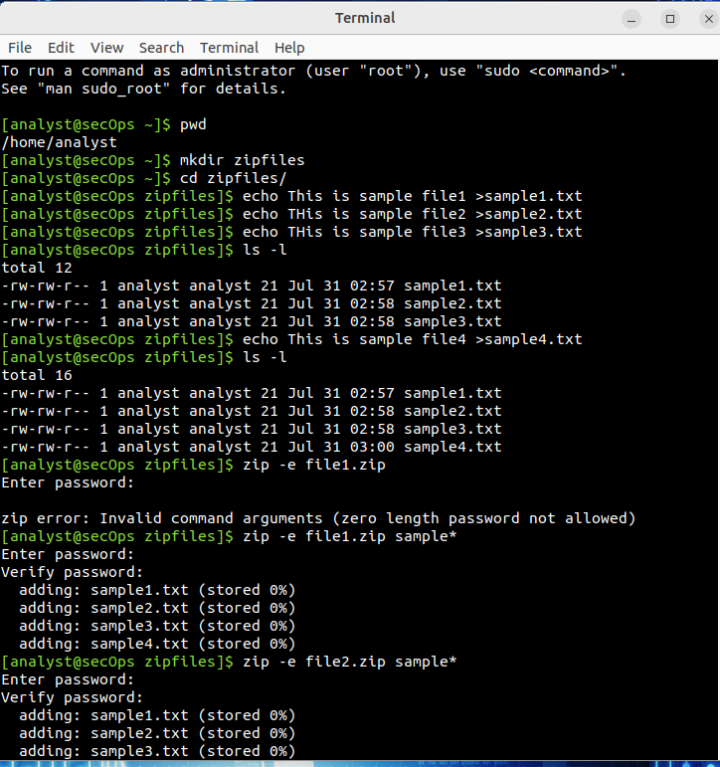
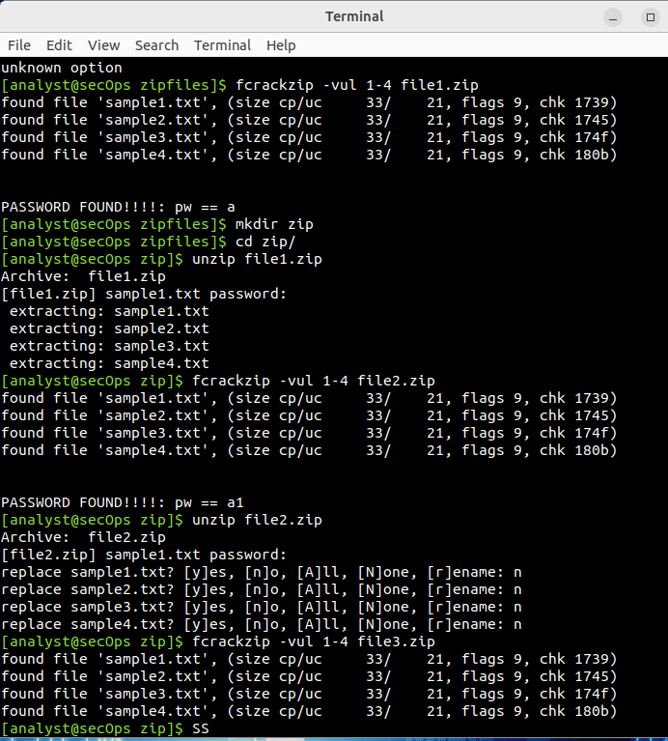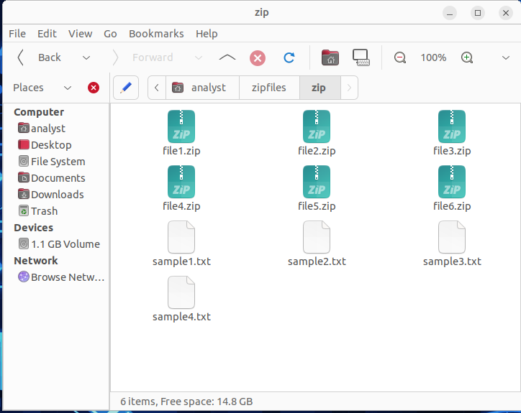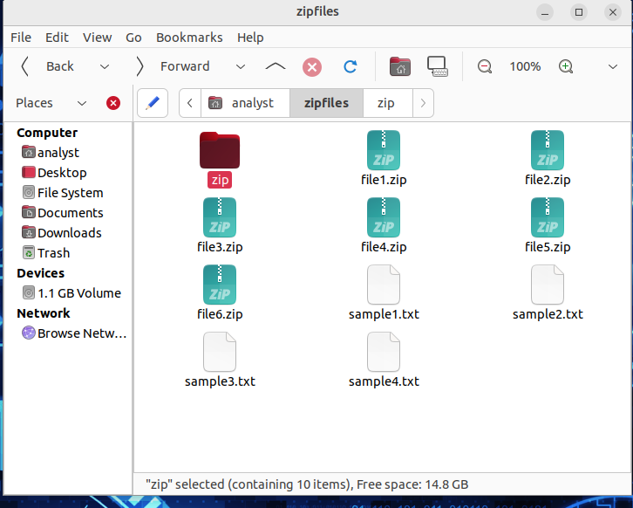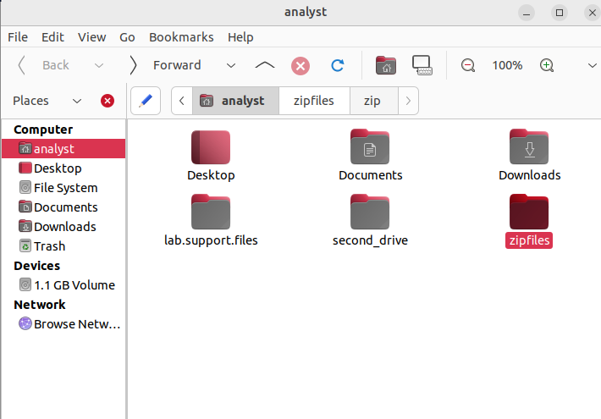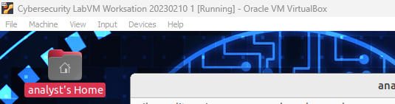

Practical 1B: Encryption and Decryption data using OpenSSl.
Go to the folder where “letter_to_grandma.txt” is saved. It is saved in folder lab.support.files.
Now we need to open the file in terminal, so for that the following command is
$cd lab.support.files/
$ls
$cat letter_to_grandma.txt

• Navigate to the file location
- The file letter_to_grandma.txt is saved in the lab.support.files folder.
- Open the terminal and change the directory:
- cd lab.support.files/
• List the files
ls
- This confirms that letter_to_grandma.txt is present.
• View the file content
cat letter_to_grandma.txt
- This displays the text that you will encrypt.
• Encrypt the file (Command likely used, though not shown in your doc)
Example with AES-256:
openssl enc -aes-256-cbc -in letter_to_grandma.txt -out letter_to_grandma.enc
- You will be prompted to enter and confirm a password.
• Decrypt the file (Command likely used)
openssl enc -aes-256-cbc -d -in letter_to_grandma.enc -out letter_to_grandma_decrypted.txt
- Enter the same password used during encryption.

Output:
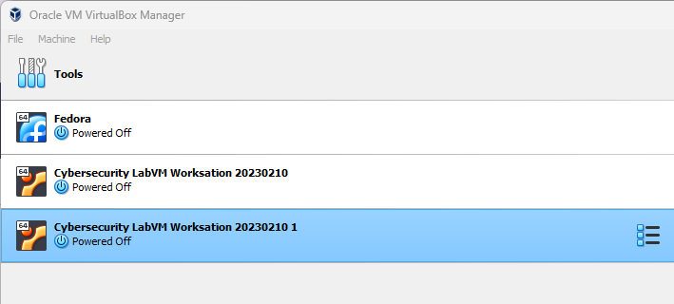
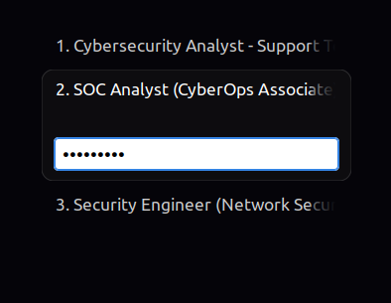
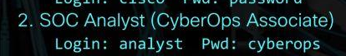
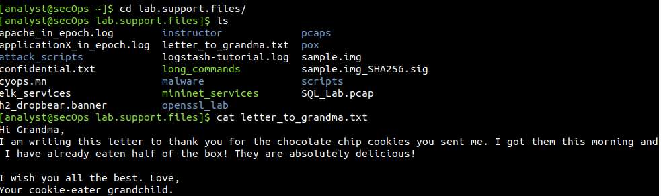
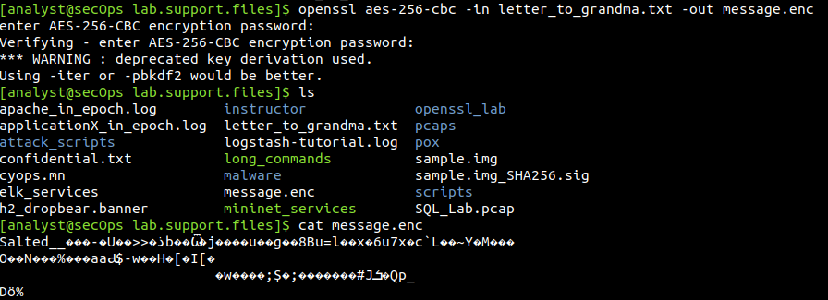
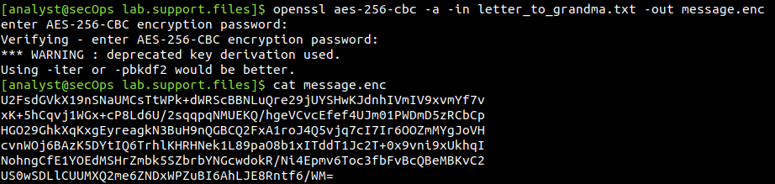
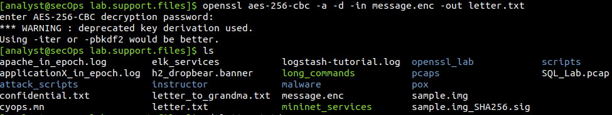
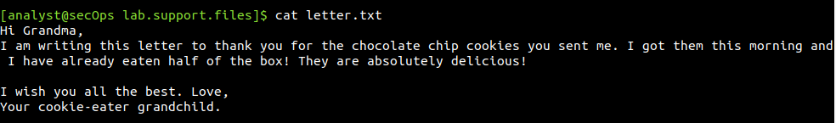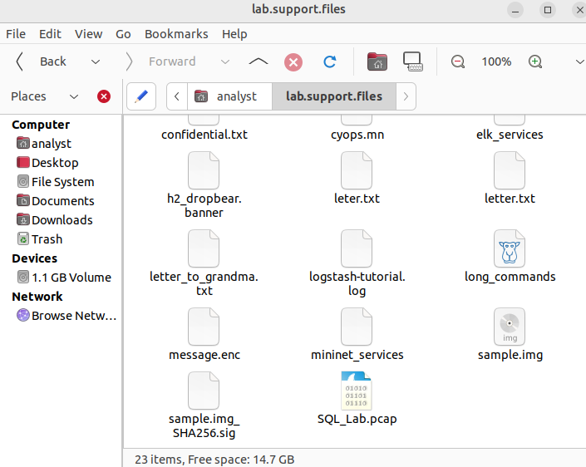
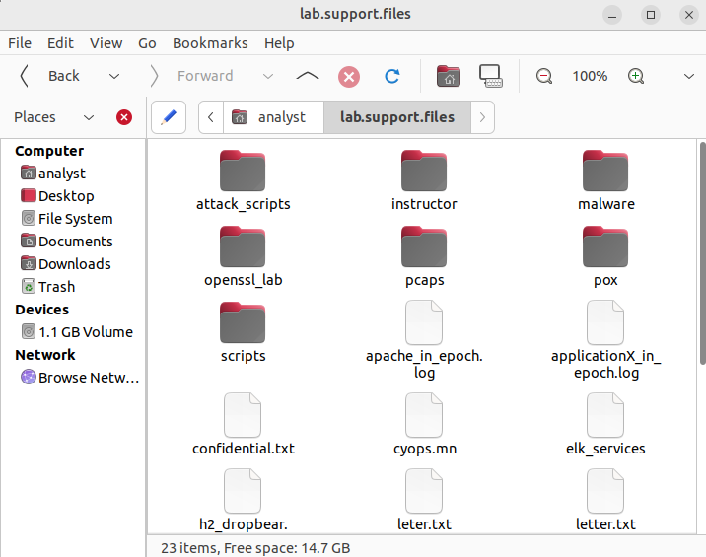

Practical 1C: Hashing a text file with OpenSSL and verifying hashes.
- Navigate to the file location (same as in Practical 1B)
$cd lab.support.files/
$ls
$cat letter_to_grandma.txt
- Generate a hash (Example using SHA256)
$openssl sha256 letter_to_grandma.txt
This outputs the SHA256 hash value of the file.

- Verify the hashes

After making certain changes save it as letter_to_grandpa
$openssl sha512 letter_to_grandma.txt
$openssl sha256 letter_to_grandpa.txt
$openssl sha512 letter_to_grandma.txt
$ls –l

If both match, the file is unchanged; if not, the file has been modified.
- Verify the sample file
$openssl sha256 sample.img
$openssl sha256 sample.img_SHA256.sig

$openssl sha512 sample.img

$openssl sha512 sample.img_SHA256.sig

Output:
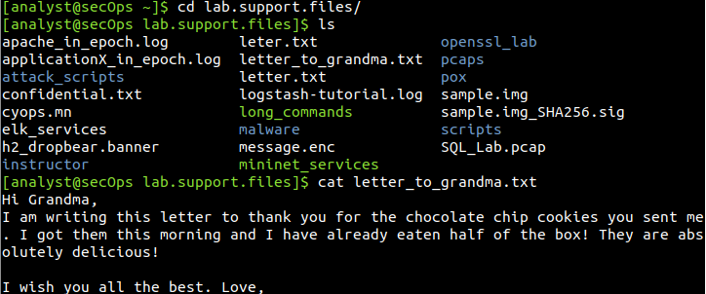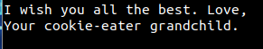

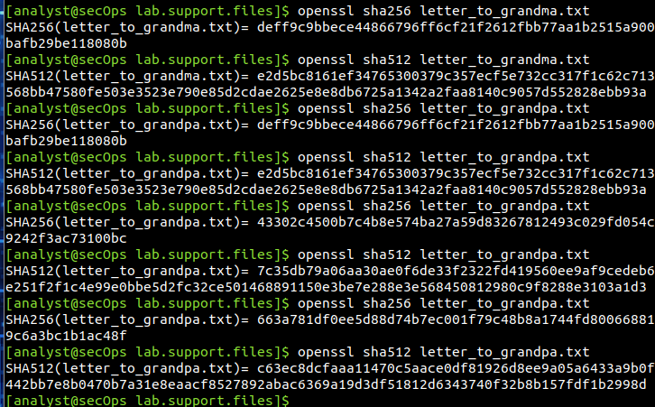
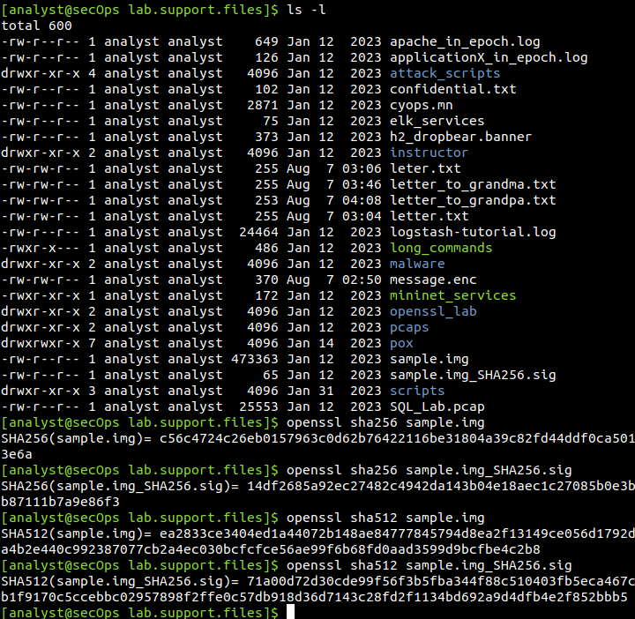

SOC_Practical#2
2a:- Examining telnet and SSH in wireshark
Telnet:-
- Double-click and open wireshark from virtual machine’s desktop. (Note: First open wireshark then start telnet connection)
- Select the loopback:lo interface.
- Open the terminal and run:
$telnet localhost
- Enter the username: analyst and password: cyberops when prompted.
- In the wireshark window, you will see the packets sent and received. Select any packet, right-click and choose Follow -> TCP Stream.
- The username and password will be displayed in plain text.

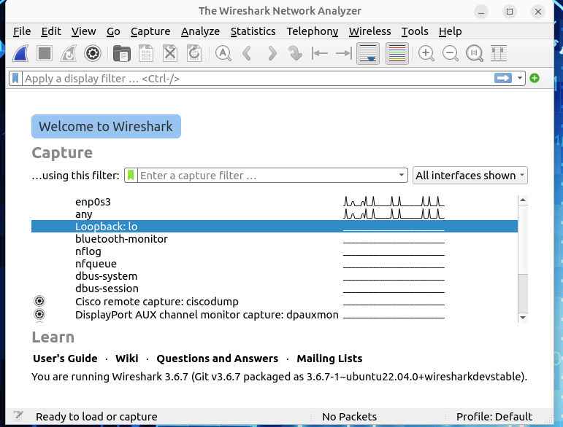
$telnet localhost
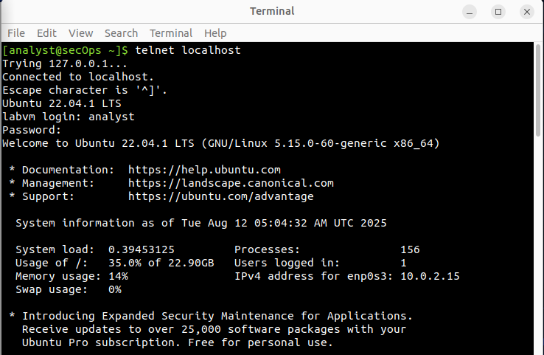

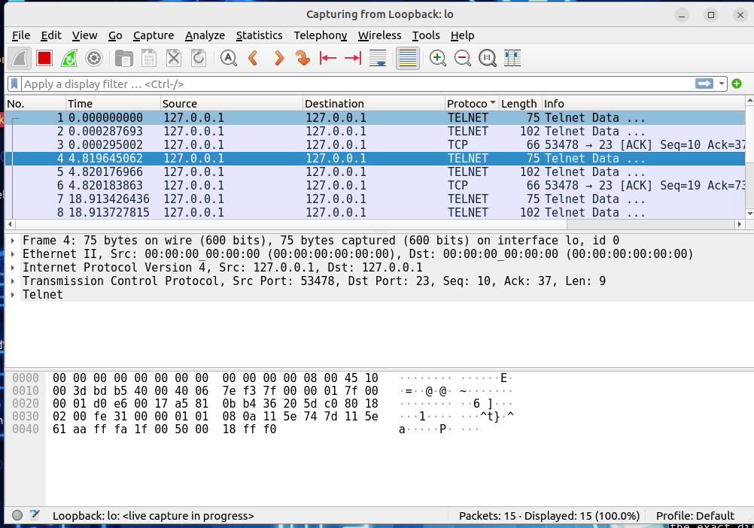
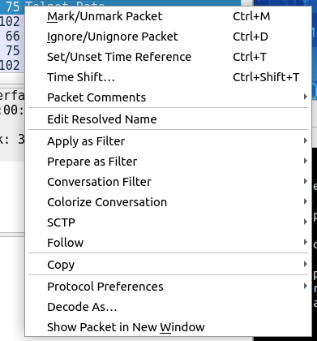

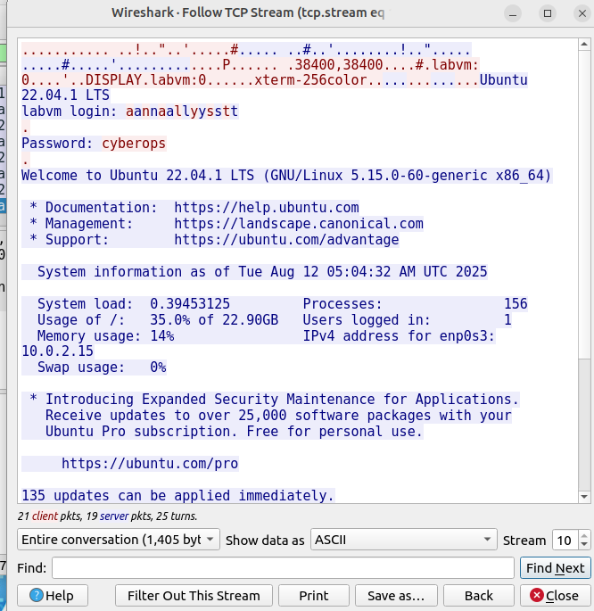
SSH:-
- Double-click and open wireshark from virtual machine’s desktop. (Note: First open wireshark then start ssh connection)
- Select the loopback:lo interface.
- Open the terminal and run:
$ssh localhost
- Enter the password: cyberops when prompted.
- In the wireshark window, you will see the packets sent and received. Select any packet, right-click and choose Follow -> TCP Stream.
- The username and password will appear in an encrypted format.
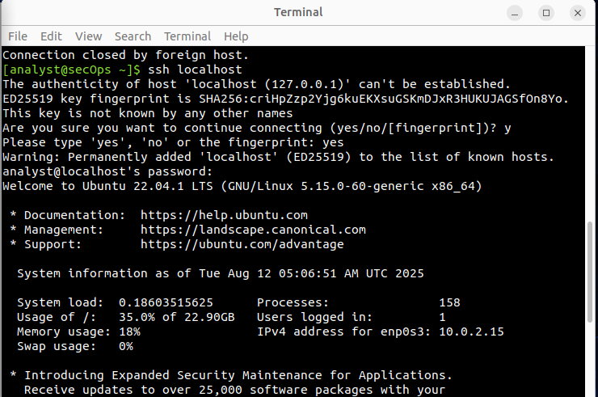
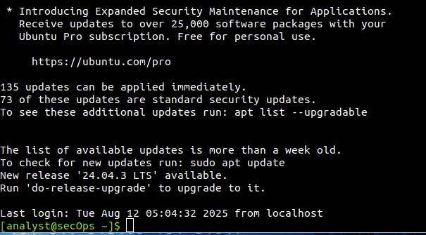
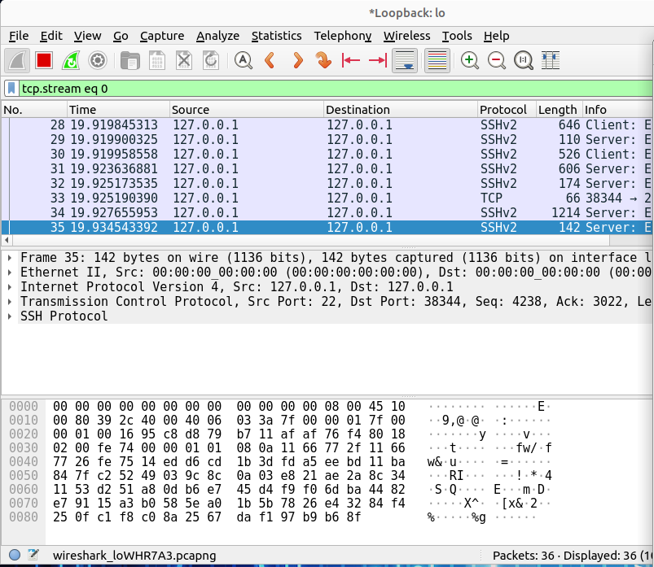
Algorithms by client side
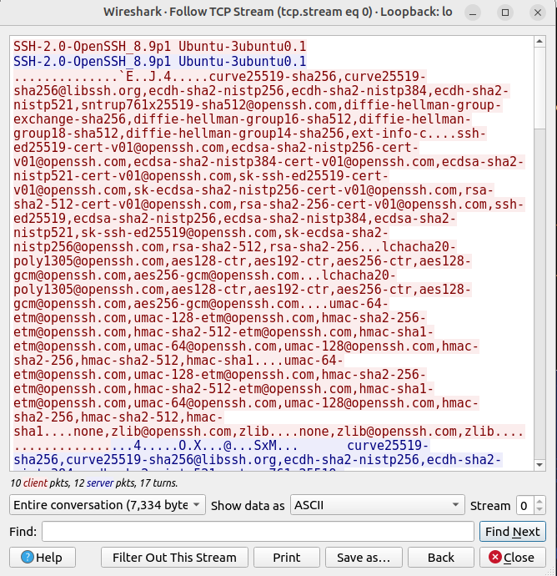
This part shows algorithms supported by server
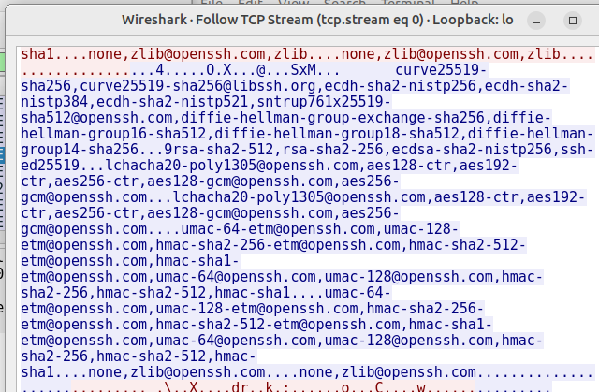
This part shows username
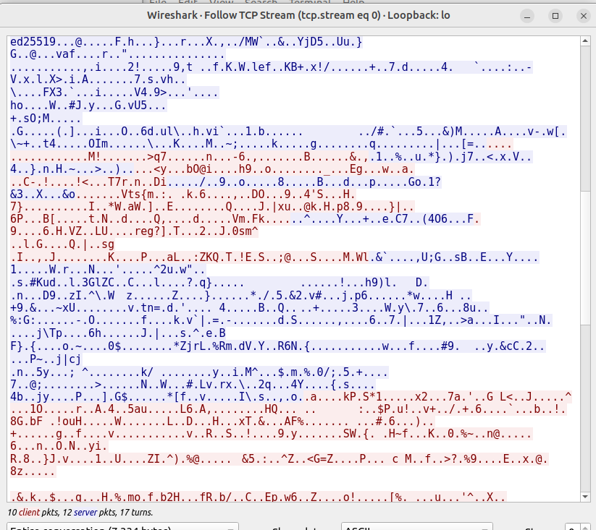
This part shows password
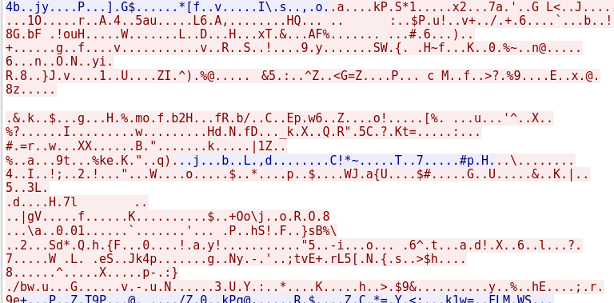
This part shows docementation
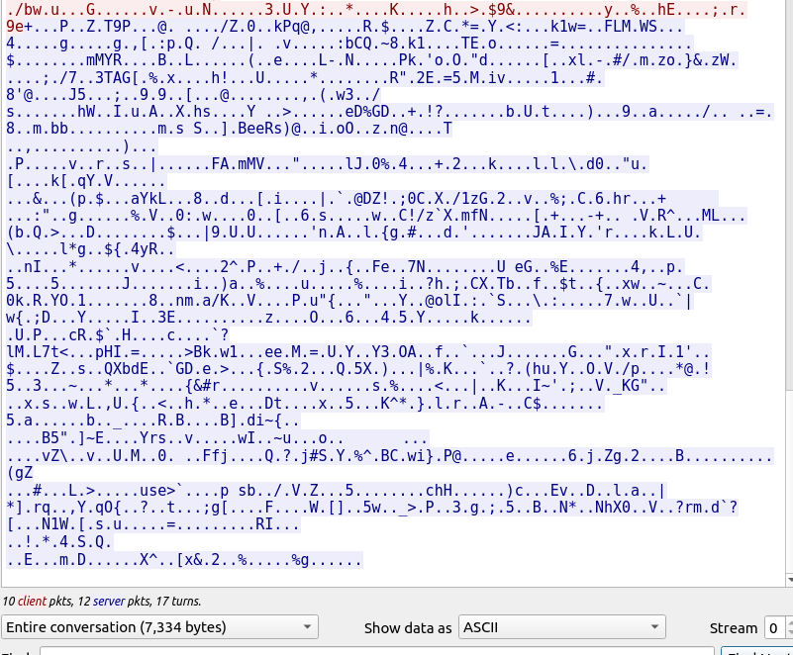

Practical 2b:
Start the wireshark

Practical 3b:
Ways to open a file
- Files can be open in GUI mode (eg. Analyst Folder -> lab.support.files -> pcaps -> nimda.download.pcap
- Open wireshark through GUI wireshark -> File -> Open -> Select “nimda.download.pcap”
- Through terminal:
$ cd lab.support.files/
$ cd pcaps/
$ ls
$wireshark nimda.download.pcap &

& is used to run wireshark without disabling the terminal because when we run wireshark command it does not allow to use terminal.
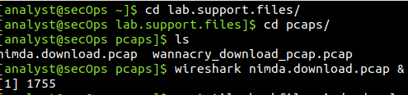

File in wireshark -> export objects -> http ->

Ls
File W32.Nimda.Amm.exe

